**AIRBNB CASE STUDY**

**BackGround** - AIRBNB, Inc. is an American vacation rental online marketplace company based in San Francisco, California, United States. AIRBNB offers arrangement for lodging, primarily homestays, or tourism experiences.Due to COVID situation, AIRBNB has seen drop in revenue.Once COVID situation is uplifted, AIRBNB wants to be fully prepared with their precautionary measures & new changes.

**Objective** - Improve understanding about market condition post COVID situation.

* Improve safety measures for customer and understanding their requirements.
* Provide early recommendations to the team to improvise customer service.

*We started analyzing dataset using python, plotly and tableau. Below are the in detailed steps and visuals performed for analysis.*

**Import Required Libraries -**

import pandas as pd

import plotly

import plotly.graph_objects as go

from plotly import graph_objs as go

from ipywidgets import widgets

from IPython.display import display

plotly.offline.init_notebook_mode(connected=True)

import matplotlib.pyplot as plt

import matplotlib.image as mpimg

%matplotlib inline

import seaborn as sns

import warnings

warnings.filterwarnings('ignore')

**Step 1 - Reading and Cleaning DataSet**

> Read dataset using pandas library.

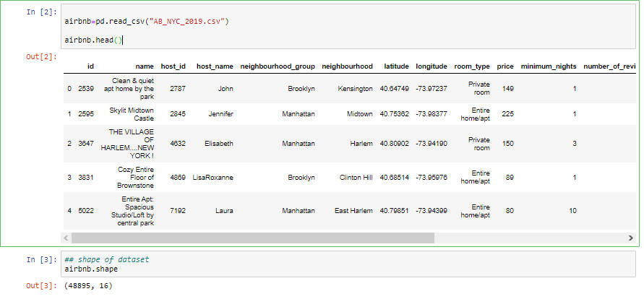

> Checked for the null values and dropped unnecessary columns. As we found name, id , host_Name and last_review as not essential columns for analysis so dropped it.

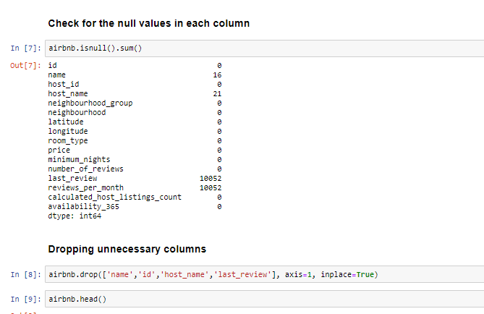

> Replace reviews per month with '0' and also checked for NAN values in dataset.

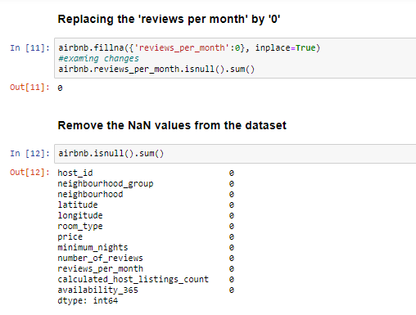

> Once data cleaning was done final dataset has 48895 rows and 12 columns.



**Step 2 - Data Visualization Using Python**

**UNIVARIATE ANALYSIS -**

**1. Neighbouring Group - Newyork have five neighbourhood. All the listings in dataset belong to either one of them. We can visualize which neighbourhood has dense Airbnb listings.**

**Code snippet -** airbnb['neighbourhood_group'].value_counts()

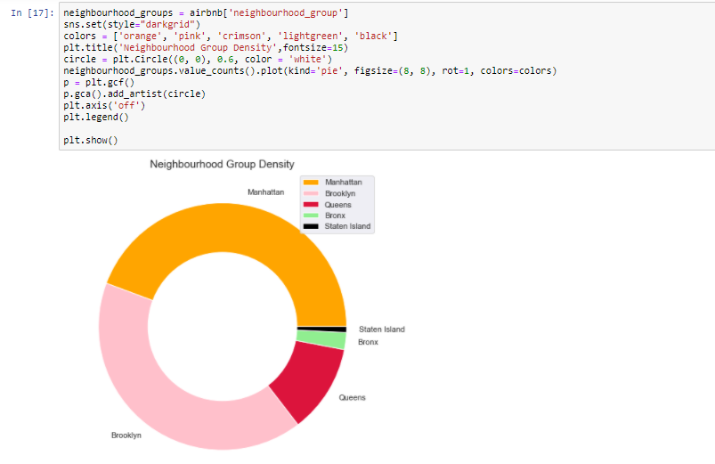

**We can observe that Brookly and Manhattan are densly populated with Airbnb listings. It's pretty obvious that both Manhattan and Brookly are famous for tourism.**

**2. ROOM TYPE - Three types of rooms are availble in Airbnb listings. Lets just observe their weightage among the city.There are more Private Rooms and Entire home type.**

**Code Snippet -**

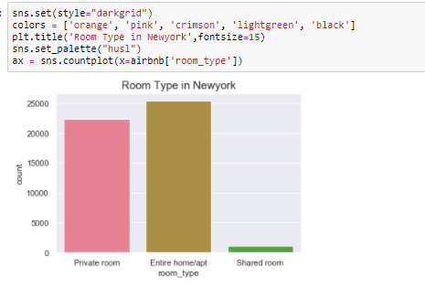

**Since no of shared rooms , are Significantly less , there is no harm in saying that people who normally use Airbnb service to visit New York City, are probably NOT that keen on saving.**

**3. PRICE DISTRIBUTION -**

**Code Snippet -**

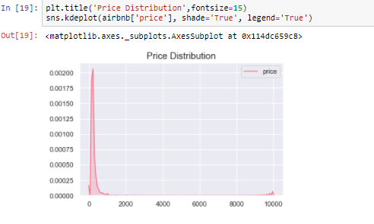

**We can observe that prices of listing start from less than 100 and maximum price reaches around 10000. The distribution curve shows that most of listings prices ranges below 500.**

**4. MINIMUM NIGHTS -**

**Code Snippet -**

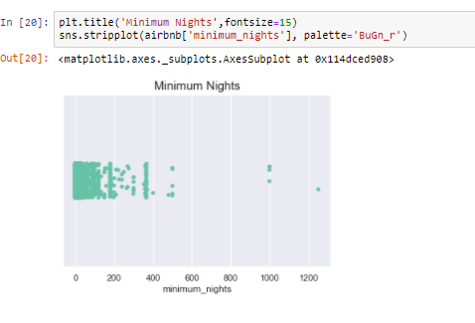

**There are listing which are providing service ranging from 1 night to 3 years. Most of the distribution is between 1night to 1 year.**

**5. Availability 365**

**Code Snippet -**

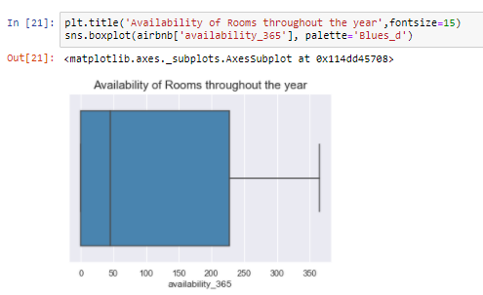

**The mean of availability is around 110 which indicates probability of finding a room is 1/3 through out an year.**

## 6. Top 10 most popular Airbnb hosts

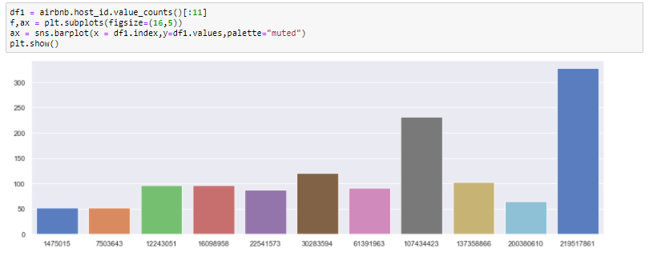

**This is the list of top 10 most popular host in the given neighbourhood groups. Maximum number of people love to stay at their place. The reason behind their popularity may depend upon the price, neighbourhood, cleanliness and many more.**

**BIVARIATE ANALYSIS-**

**1. Checking the number of reviews for each neighbourhood group**

**Code Snippet -**

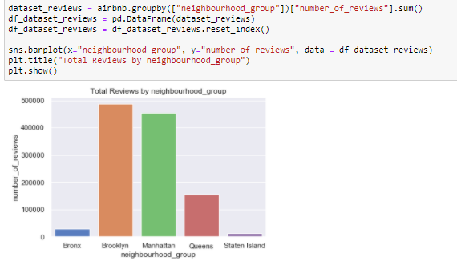

**2. Checking the proportion of "private_room", "entire apt" and "shared room" for each "neighbourhood_group"**

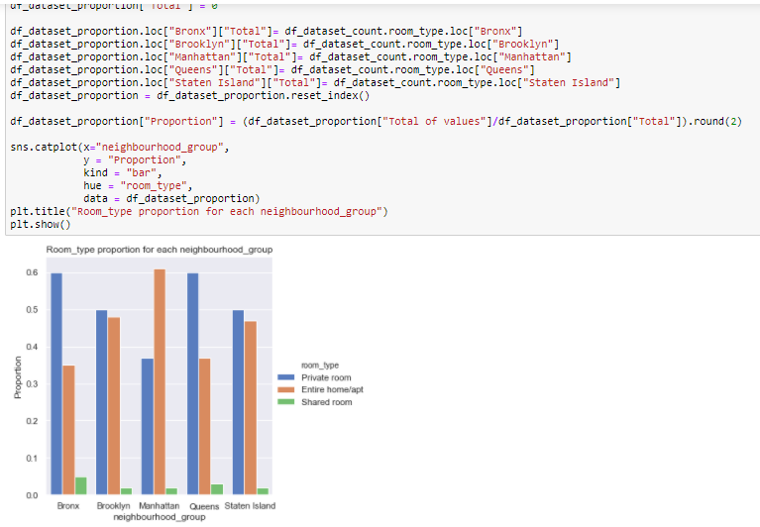

**3. Look at what neighboourhood are the most expensive and least expensive**

**Code Snippet -**

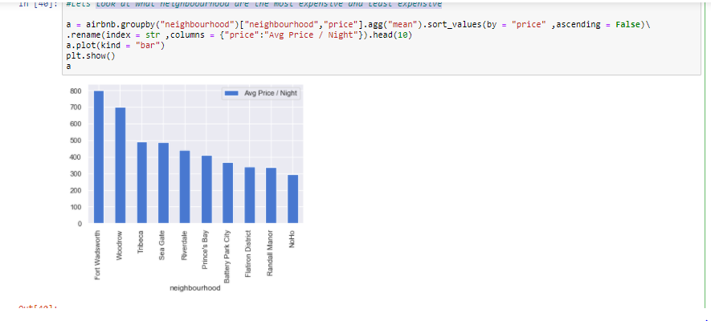 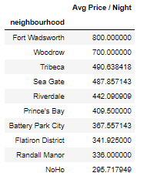

### Fort Wadsworth seems to be the most Expensive neighbourhood on avg out of 221 total neighbhourhoods

**STEP 2 -VISUALIZATION USING PLOTLY**

**1. 3-Dim Plot of Price vs Minimum Nights of Stay vs Number of Reviews**

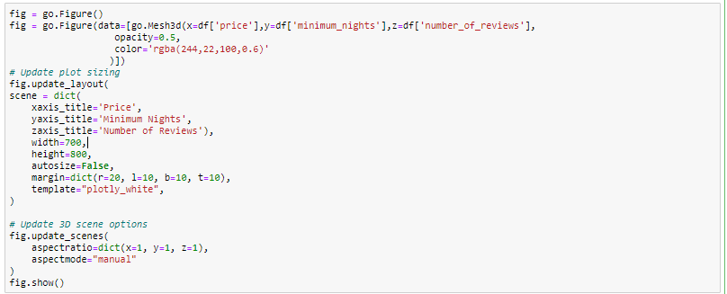

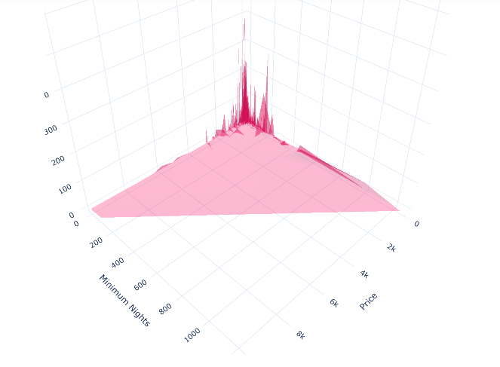

**- 3D plot explains, properties with higher number of minimum nights of stay and higher price has no reviews and vice versa**

##### **2. *Room Type Contribution with in each Neighbourhood Groups***

**Code Snippet -**

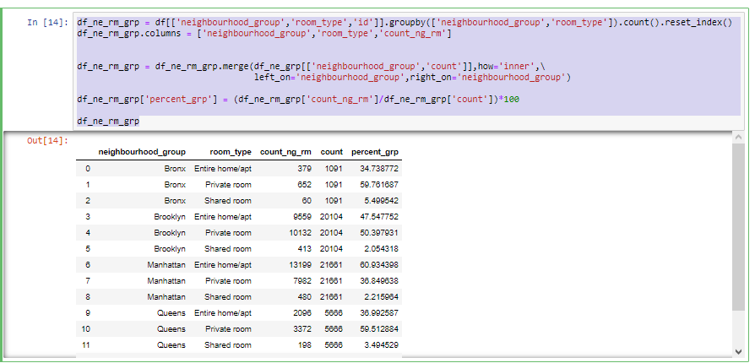

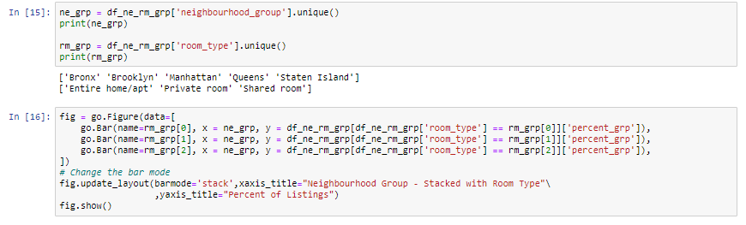

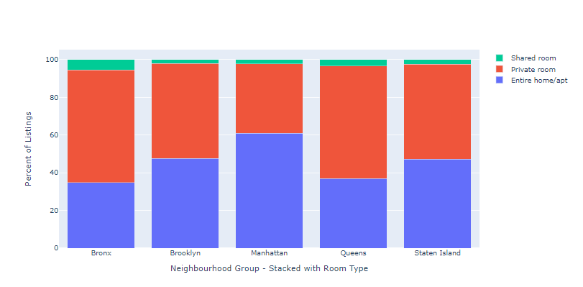

**Overall Room Type:**

**Entire home/apt 51.96**

**Private room 45.66**

**Shared room 2.37**

**Major difference in contribution of Overall Room Type and Within Neighbour Group (based on delta percentage calculation):**

**Manhatten has (60.9 - 51.9)/60.9 = 14.7% higher contribution of Entire home/apt compared to the Overall Contribution of Entire home/apt**

**Queens has (59.5 - 45.66)/59.5 = 23.2% higher contribution of Private room compared to the Overall Contribution of Private room**

**3. Price vs Number of Review**

**Code Snippet -**

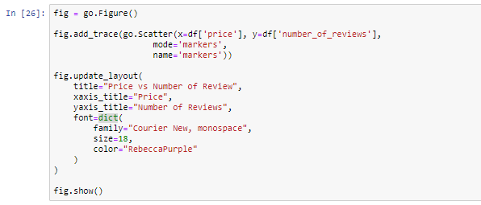

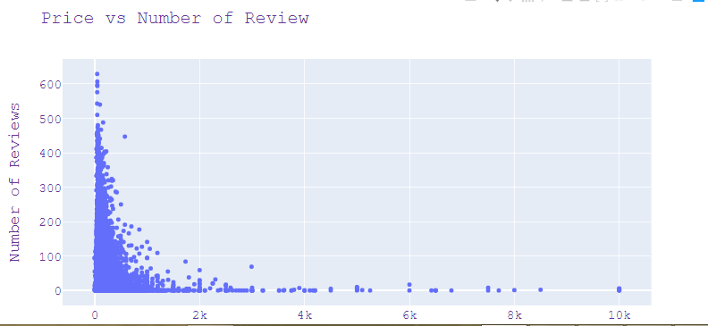

**- Scatter plot between 'Price' and 'Number of Reviews' explains, properties with less price has more number of reviews which in turn means more bookings for properties with less price.**

**STEP 3 -SOME VISUALIZATION USING TABLEAU -**

**After data cleaning, some visualization is done using tableau by import excel file in tableau desktop.**

**1. Room Type Vs Calculated Host Listings**

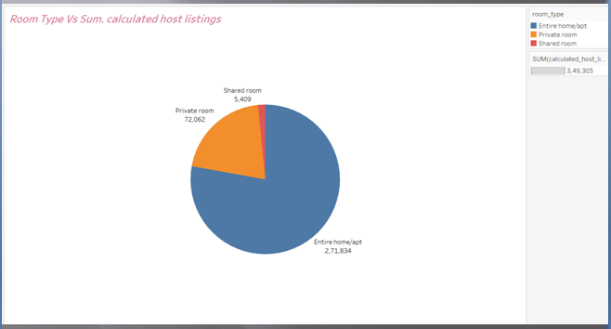

**Contribution Room Types of Listing Properties:**

**- Entire home/apt(51.96%) and Private Room(45.66%) => 97.63% is major part of the properties listed.**

**- Only 2.37% is the contribution of shared room properties listed.**

**2. Few more**

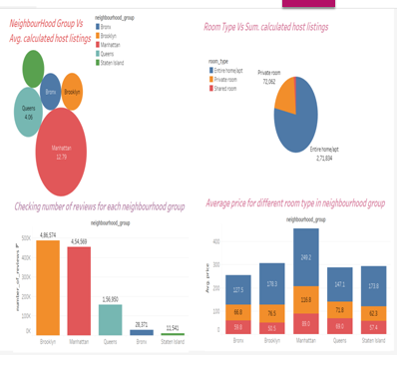

* **Manhattan and Brooklyn are the key neighbourhood groups which are in demand based on host listings.**
* **Major booking which happen is for the Entire Home/Apt and least is for shared – therefore focus should be on these two.**
* **Brooklyn and Manhattan has more demand of Entire Home/Apt booking based on average price.**
* **It's pretty obvious that both Manhattan and Brooklyn are famous for tourism.**

**3. Top 10 host id based on reviews.**

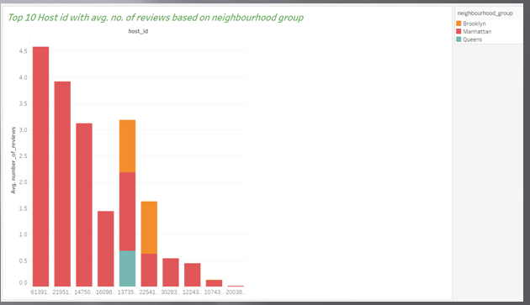

* **Manhattan and Brooklyn have most number of reviews in top 10 host id list.**
* **Top Hosts make their money from Brooklyn and Manhattan .**

**KEY FINDINGS -**

* **Manhattan and Brooklyn are the key neighbourhood groups which are in demand based on host listings.**
* **Major booking which happen is for the Entire Home/Apt and least is for shared – therefore focus should be on these two.**
* **Brooklyn and Manhattan has more demand of Entire Home/Apt booking based on average price.**
* **Manhattan and Brooklyn are mostly preferred for minimum night for stay.**
* **Manhattan and Brooklyn are probably well received in terms of reviews because they are the centers of attraction .Every listing in those locales are mostly built in a way that makes a Tourist feel at home .**
* **It's pretty obvious that both Manhattan and Brooklyn are famous for tourism.**

**THANK YOU!**